Creating a Development Lifecycle

# Revision

Version 3

12/13/22 2:41 PM

# Author

Charles Wilson

# Abstract

This document describes the methodology used to create a development lifecycle that can be aligned to an overarching Product Development Lifecycle (PDL).

# Motivation

The complexity of developing large-scale systems is such that it is necessary to have well thought out processes and frameworks supporting their development. One element of such is a development lifecycle whose framework is aligned to an overarching framework and which provides actionable guidance directed to the groups and individuals responsible for implementation of its process requirements. It also provides information critical to the scheduling and resource allocation of the system to be developed. Finally, it supports certification efforts, by formally establishing procedures and the means by which they are evaluated for maturity.

# Audience

The audience of this document are those tasked with creating development lifecycles.

**Note:** This document is not subject to certification body review.

# License

This work was created by **Motional** and is licensed under the **Creative Commons Attribution-Share Alike (CC BY-SA-4.0)** License.

[**https://creativecommons.org/licenses/by/4.0/legalcode**](https://creativecommons.org/licenses/by/4.0/legalcode)

# Overview

This document describes the material needed to create a development lifecycle primary document. It is presumed that those undertaking this activity are well versed in development lifecycles, inter-group dependency management, and the standards within their domain.

A template for this is provided in the **reference_documents / templates /** **lifecycle template** folder.

# Decomposition

Any development lifecycle document can be decomposed as follows:

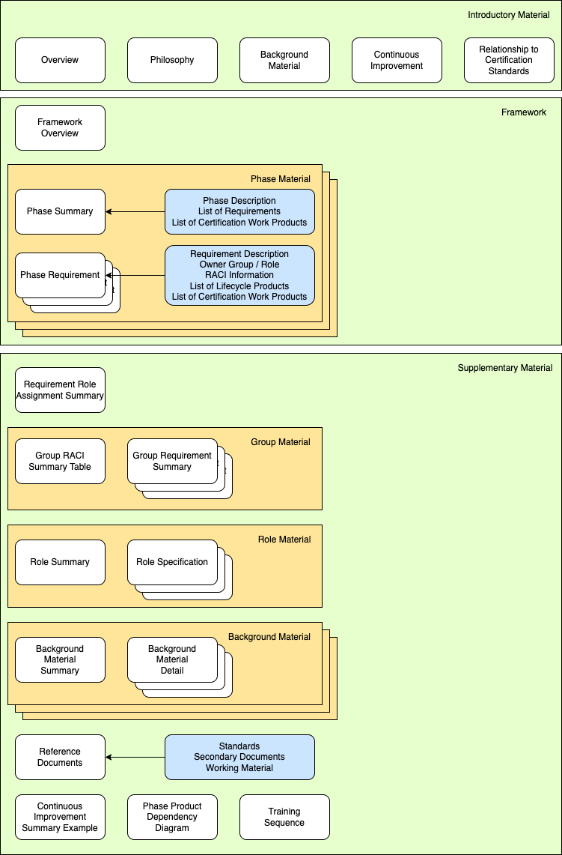

## Introductory Material

The import of the introductory material cannot be overstated. Although not of interest to the majority of those impacted by the adoption of the development lifecycle, it provides valuable information as to the drivers of the lifecycle.

### Overview

The overview provides the context for the development lifecycle. The overall shape of the lifecycle is presented, as well as, its relationship with other frameworks.

### Philosophy

The philosophy section presents a less technical and more motivational description of the lifecycle.

### Background Material

From the background material we are introduced to the foundational information which drove the construction of the lifecycle. This is important both from a documentation and mindshare standpoint. From the documentation standpoint, there is the need to establish that the lifecycle is not constructed in a manner which contradicts standards considered to be established / best practices. From the mindshare standpoint, it is important to provide reference to those materials both for those maintaining the lifecycle itself and those adopting it.

### Continuous Improvement

It is recognized that no organization perfectly implements any standard. Because of this, continuous improvement and its monitoring are important both from a resourcing and reality check perspective. By tracking the maturity of all process requirements within the lifecycle itself, we are better able to allocate resources to ensure the best possible implementation of those requirements. It also gives a quantifiable metric of maturity of the same.

### Relationship to Certification Standards

The two-fold purpose of any lifecycle is to provide organizational structure and enable certification of the same. Here the relationship of the lifecycle to the certification standard(s) is explored.

## Framework

For those adopting the lifecycle, this is the most critical section of the lifecycle document. It provides detailed information as to the phases, their attendant requirements, ownership, owner role, and associated products.

### Framework Overview

The framework overview is the map providing a high-level view of the lifecycle, its phase and requirements.

### Phase Material

Every phase will be presented sequentially.

#### Phase Summary

The phase summary contains the following information:

* Phase description
* List of phase requirements
* List of certification work products

Together these provide a high-level summary of the phase.

The phase description is boilerplate as it derives from the overarching PDL.

Each of the phase requirements provides reference to the background material grounding them and a brief description of their goal.

For each certification body, a list of all applicable work products to the phase are listed.

#### Phase Requirements

Arguably the most important individual elements of the lifecycle document are its phase requirements. They are pertinent to multiple groups. Each contains the following information:

* Requirement description
* Owner group / role
* RACI information
* Training provided
* Dependent phase requirements
* External group product dependencies
* List of lifecycle products
* List of certification work products and their requirements

The requirement description provides an explanation of the goals and expectations of the requirement.

The owner group / role and RACI information make it clear as to who is the primary group responsible, what role should be undertaking implementation of the requirement and what level of participation will be forthcoming from the non-owning groups.

The list of lifecycle products shows the expected outcomes and links to the secondary document(s) relevant to attaining them.

The list of certification work products gives a definitive view of the means by which a certification is attained and how this requirement contributes toward it.

**Note:** It is the responsibility of the group responsible for the particular lifecycle to ensure that there is a correct mapping between the lifecycle products and the certification work products.

## Supplementary Material

The purpose of the supplemental material is to collect within the lifecycle document the pertinent aspects of background and summaries of information distributed throughout the lifecycle’s framework section. These allow for a deeper exploration of the underpinnings of the lifecycle and a high-level view of resource requirements.

### Requirement Role Assignment Summary

The requirement role assignment summary presents the requirement, group and role information is a tabular format.

### Group Material

The group material section provides summary information relating to the asks to the various groups

#### Group RACI Summary Table

The group summary table provides a concise view of all phase requirements and their RACI assignments.

#### Group Requirement Summaries

The group requirement summaries collect all phase requirements by group.

### Role Material

The role material collects an authoritative list of the role expectations required to implement the framework.

#### Role Summary

The role summary list the roles required within the framework.

#### Role Specifications

The role specifications provide details as the expectations for each role.

### Background Material

The background material is a collection of information extracted from various authoritative sources as called out in the introductory material’s background material section.

#### Background Material Summary

Each set of background material includes an overview / summary describing the material and its relationship to the framework.

#### Background Material Details

Each set of background material includes a collection of detailed elements extracted from their authoritative source providing a gloss.

### Reference Documents

The reference documents section provides a list for each of the following:

* Standards
* Secondary documents
* Working materials

This collects all references to these materials in a single location for ease of use.

### Continuous Improvement Summary Example

The continuous improvement summary example gives an overview of what the visualization of continuous improvement reporting would look like.

### Phase Product Dependency Diagram

The phase product dependency diagram provides information useful in the parallelization of implementation of and dependency tracking within the framework.

### Training Path

The training path provides an overview of the training provided to support the development lifecycle and the relative sequencing for the various items.

# References

1. **Autonomous Vehicle Product Development Lifecycle** (AVPDL elaboration document)
2. **Autonomous Vehicle Cybersecurity Development Lifecycle** (AVCDL primary document)